

**24F_CST8911_300 Introduction to Cloud Computing**

**Fall 2024**

**Professor Jasleen Sharma**

**Prepared By:**

**Team 11**

**Abhinav**

**Devgiri Gosai**

**Dhruv Parmar**

**Jatin Hooda**

**Karthik Raghavendra Urala**

**Shiva Reddy Sama**

**​**

The data flow diagram displays the movement of data from Azure Blob Storage, which stores raw data, via Azure Synapse Analytics for processing, and Power BI for data visualization. This configuration enables smooth data processing, storing, and display in a cloud environment that is integrated.

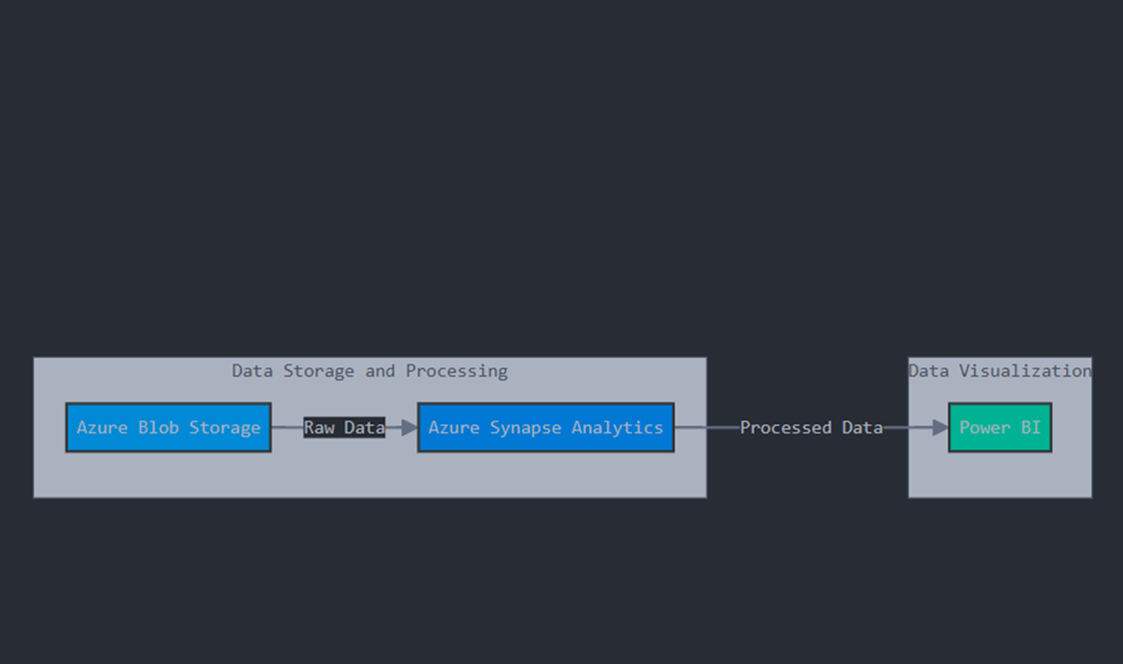

Created a Resource Group.

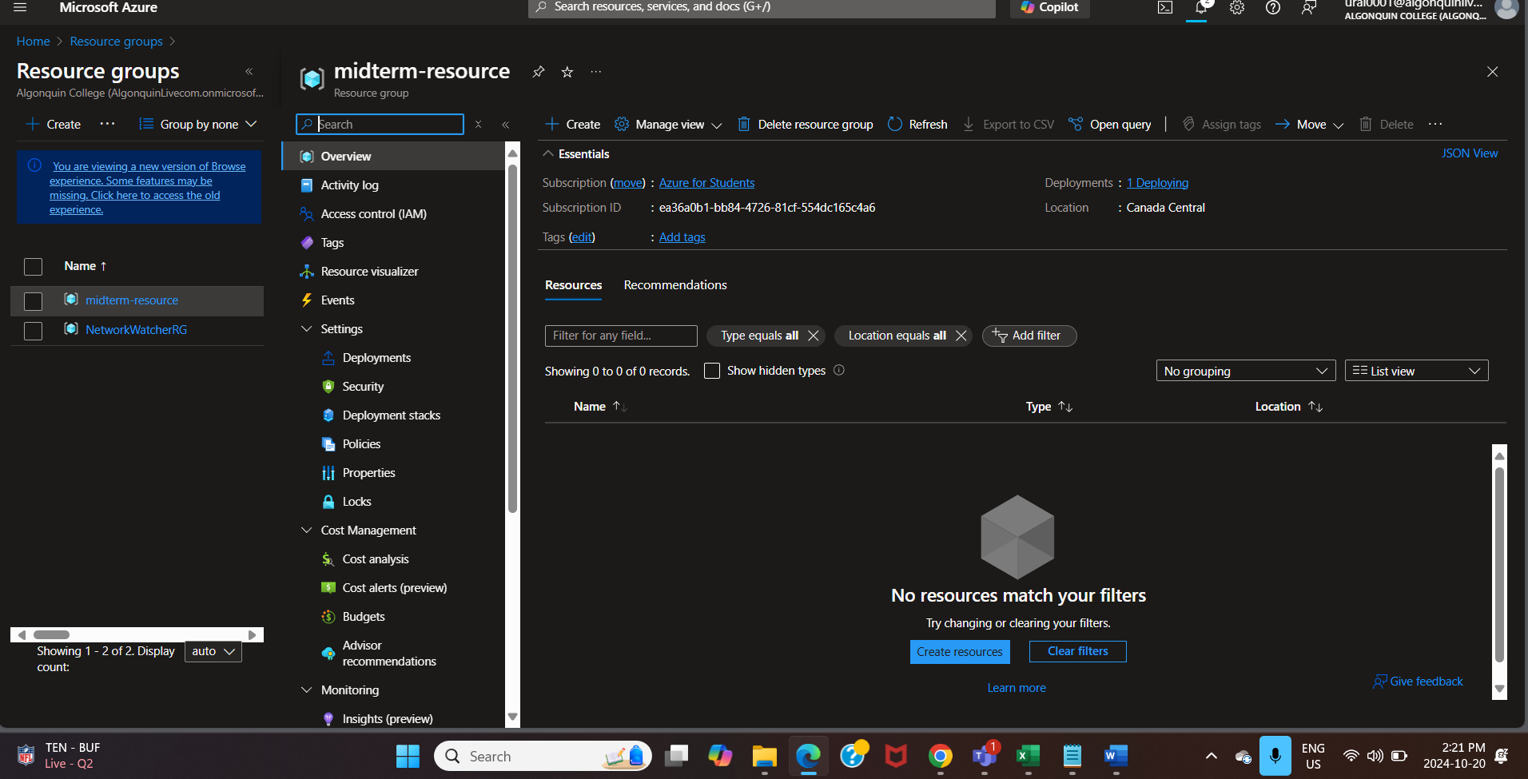

Step 1: Created a storage account .  
LRS is used instead of GRS due to LRS providing functionalities like cost-efficient, low latency and regulatory compliance.

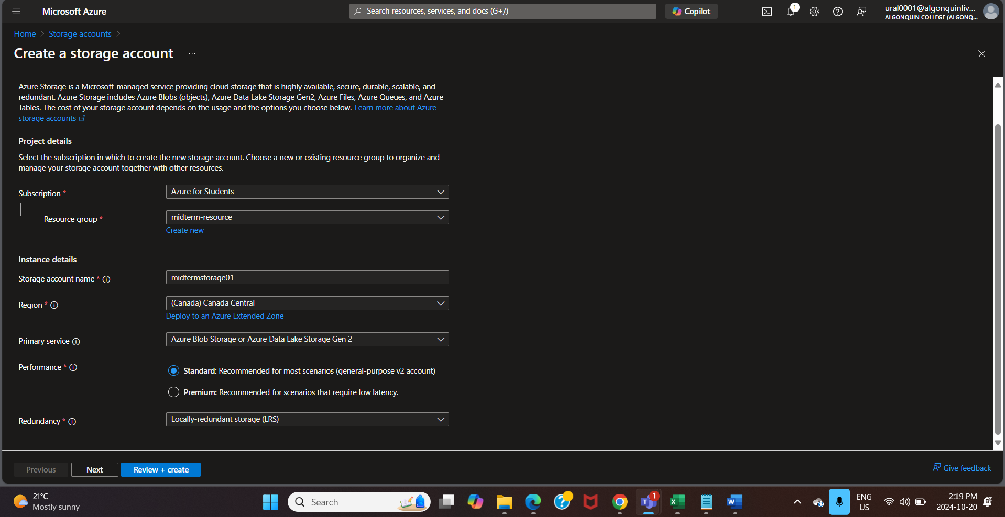

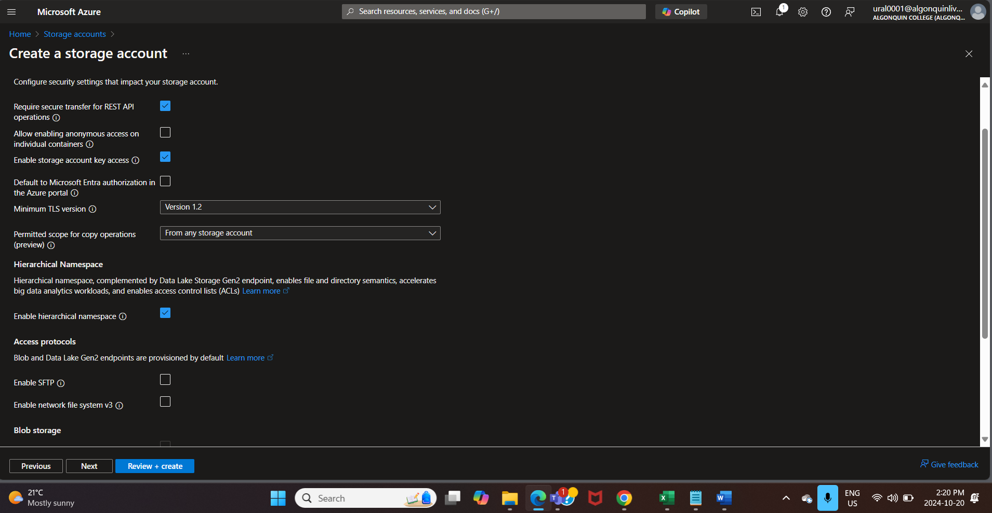

Step 2: Created a container in storage account “midtermstorage01”.

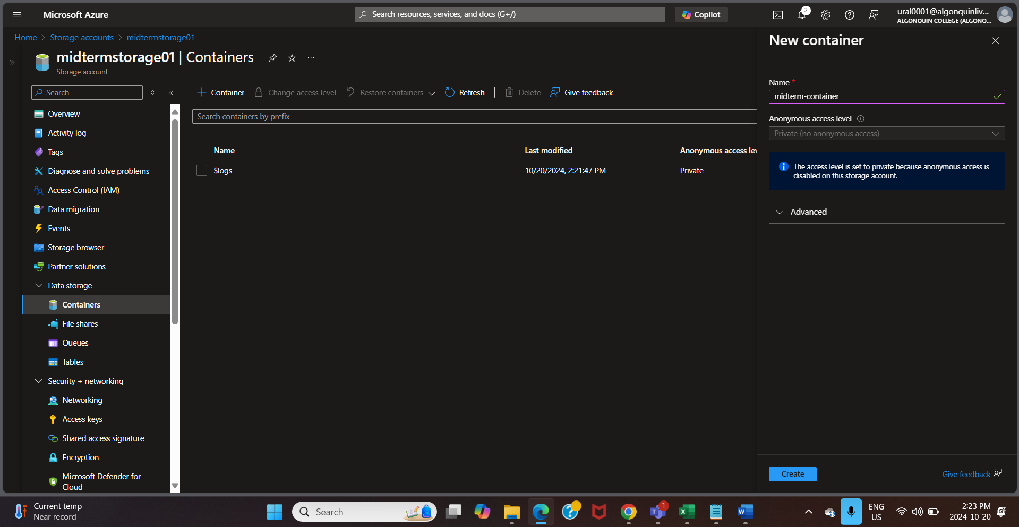

Step 3: Uploaded a dataset in the container named “midterm-dataset.csv”

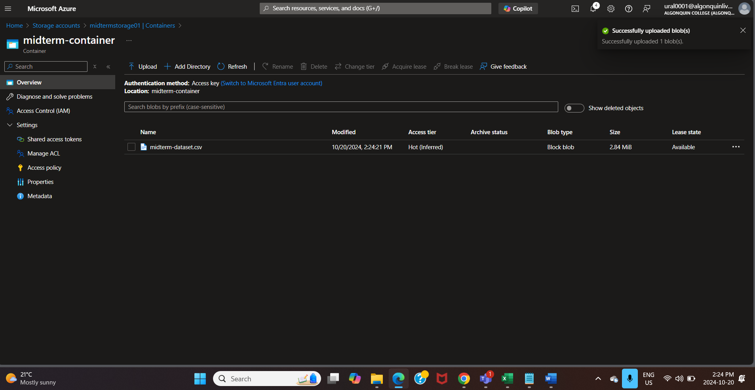

Step 4: Access Keys and connection strings which is used to authenticate and connect storage account to the SQL pool or PolyBase DB from the Azure Data Studio.

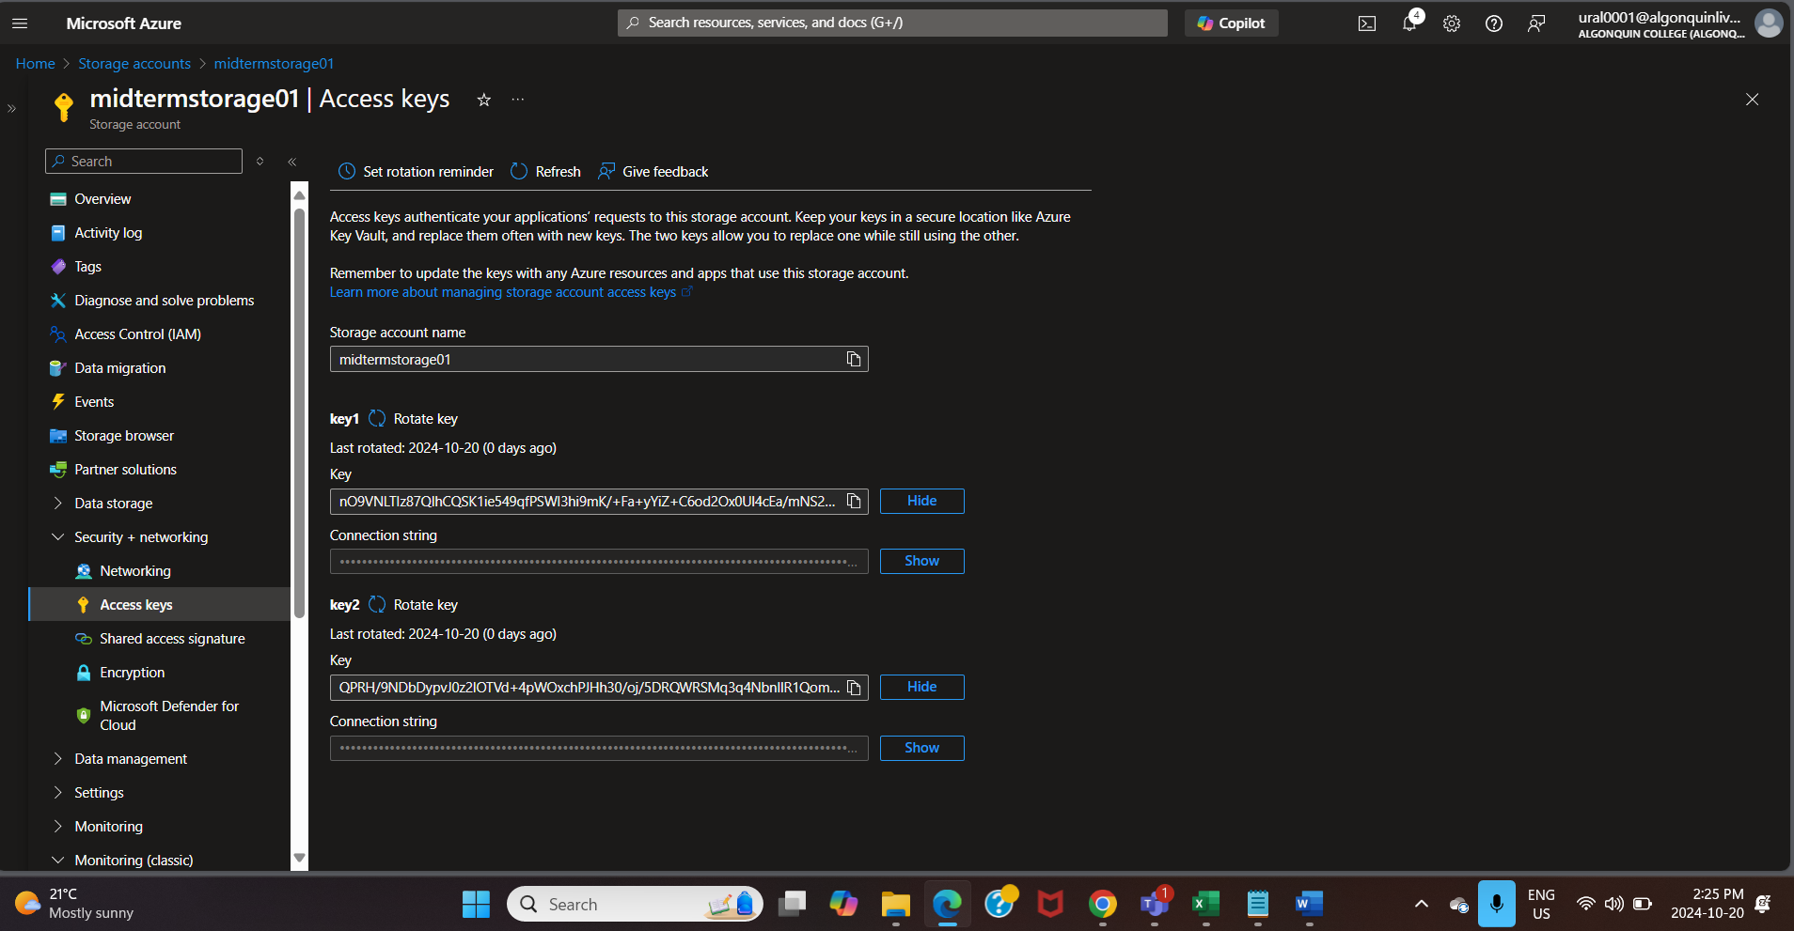

Step 5: Created a Synapse Workspace for integrating big data and data warehousing solutions. In below image as we had enabled hierarchical namespace the “Account Name” was automatically accepted which is the Storage account and the Container.

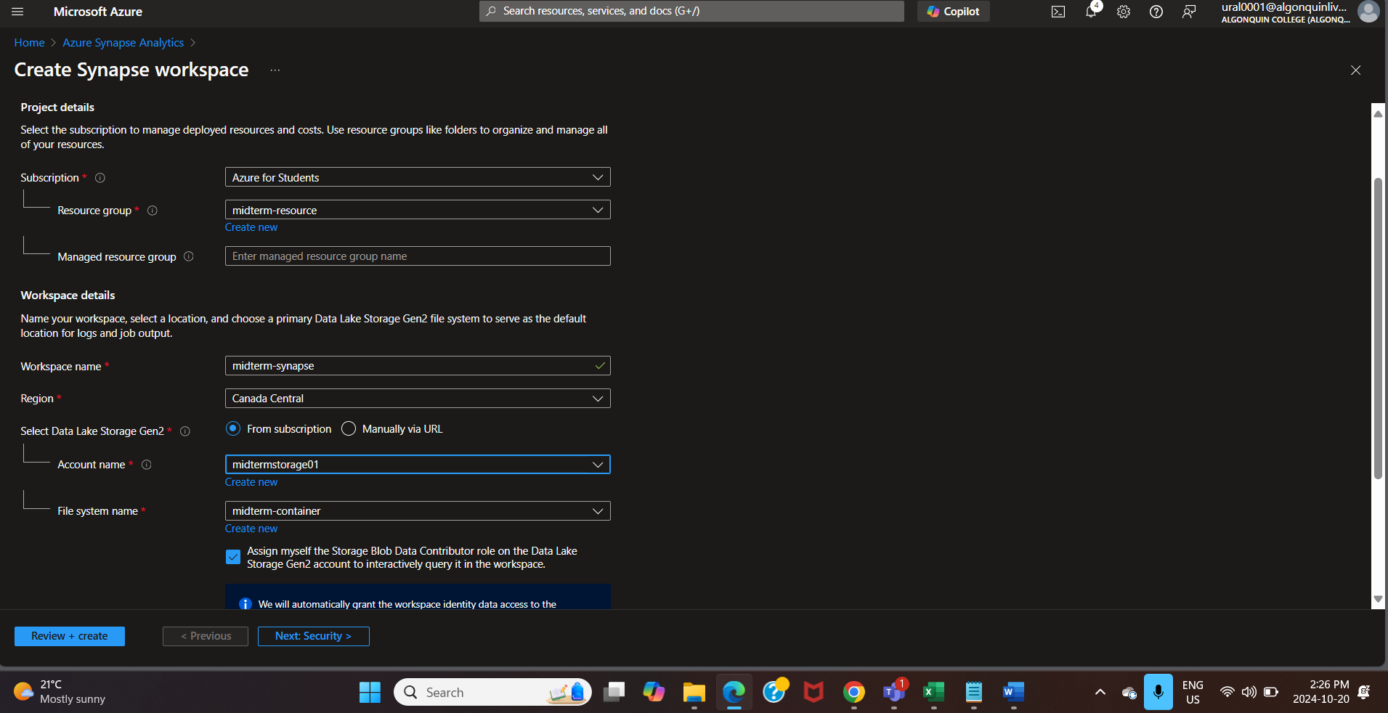

Created a new SQL user to be authenticated in the Azure Data Studio (PolyBase)

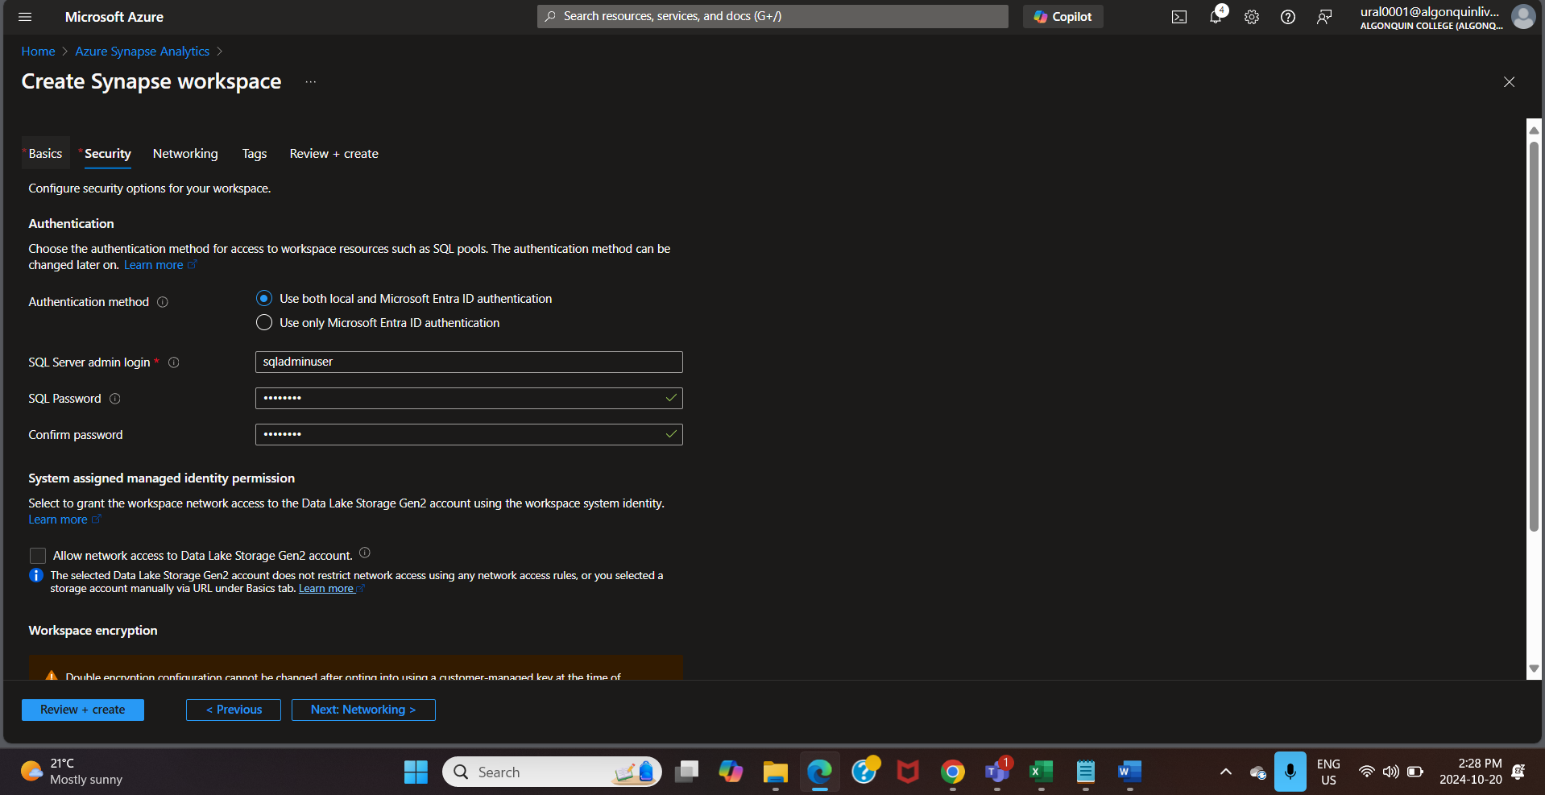

Step 6: Successfully created The Synapse Workspace.

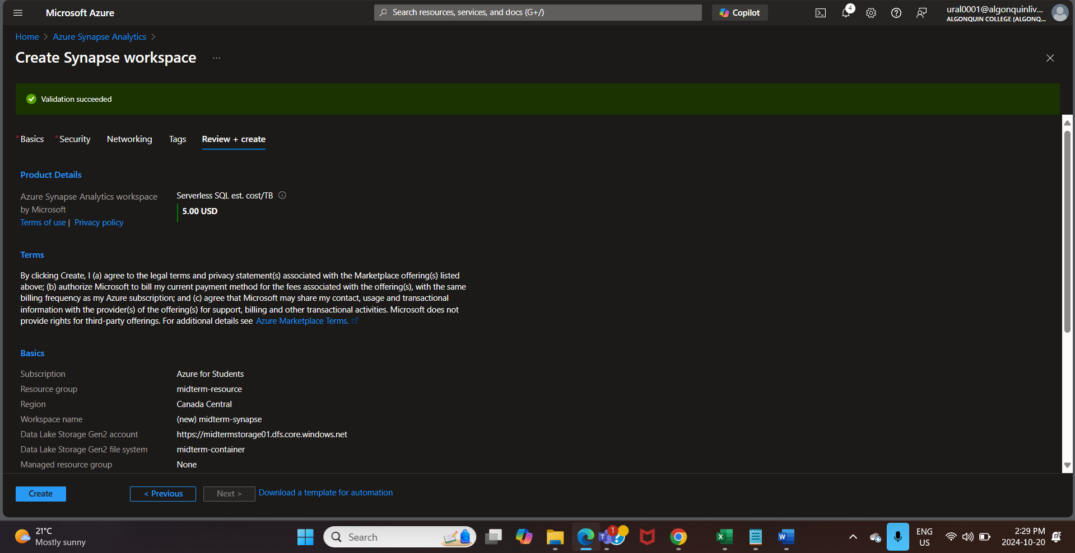

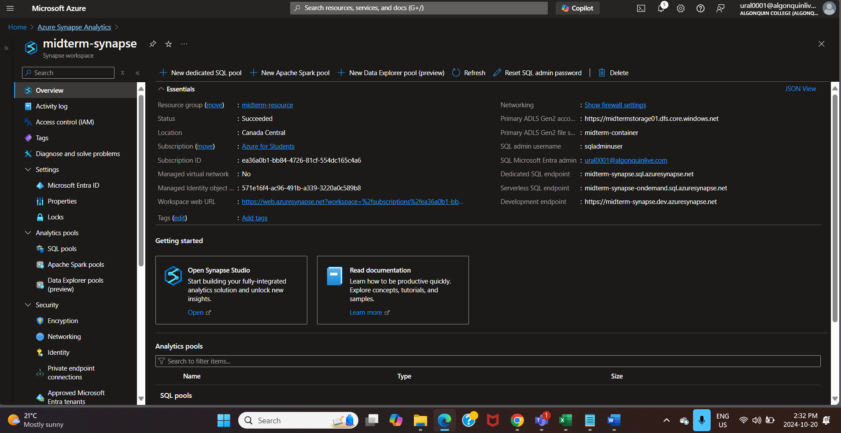

Step 7: Created a SQL pool.

A dedicated SQL pool with the performance level of DW200c called mxdedicatedpool is being established. Massive scale data warehousing capabilities are offered by this pool, enabling the execution of SQL-based queries on massive datasets.

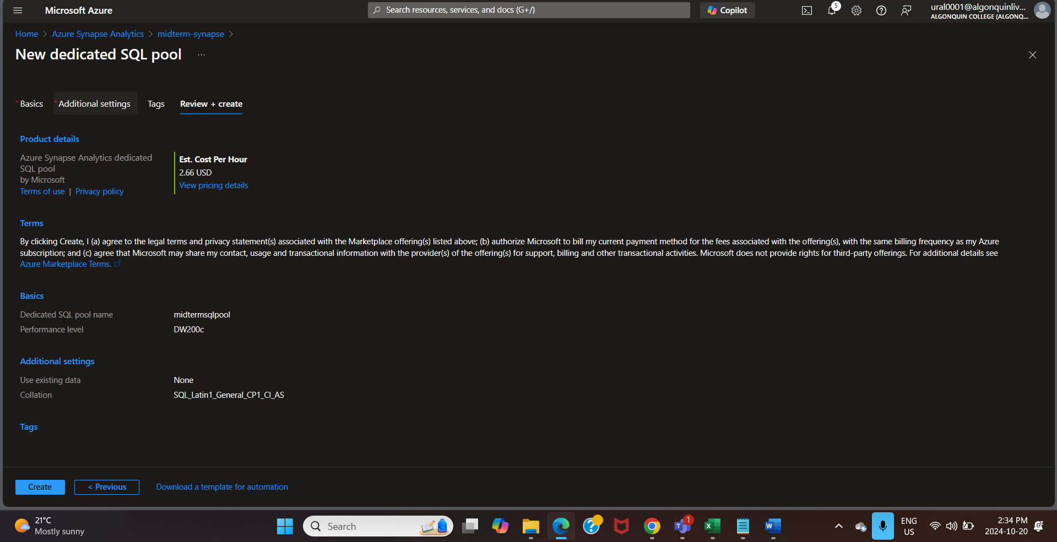

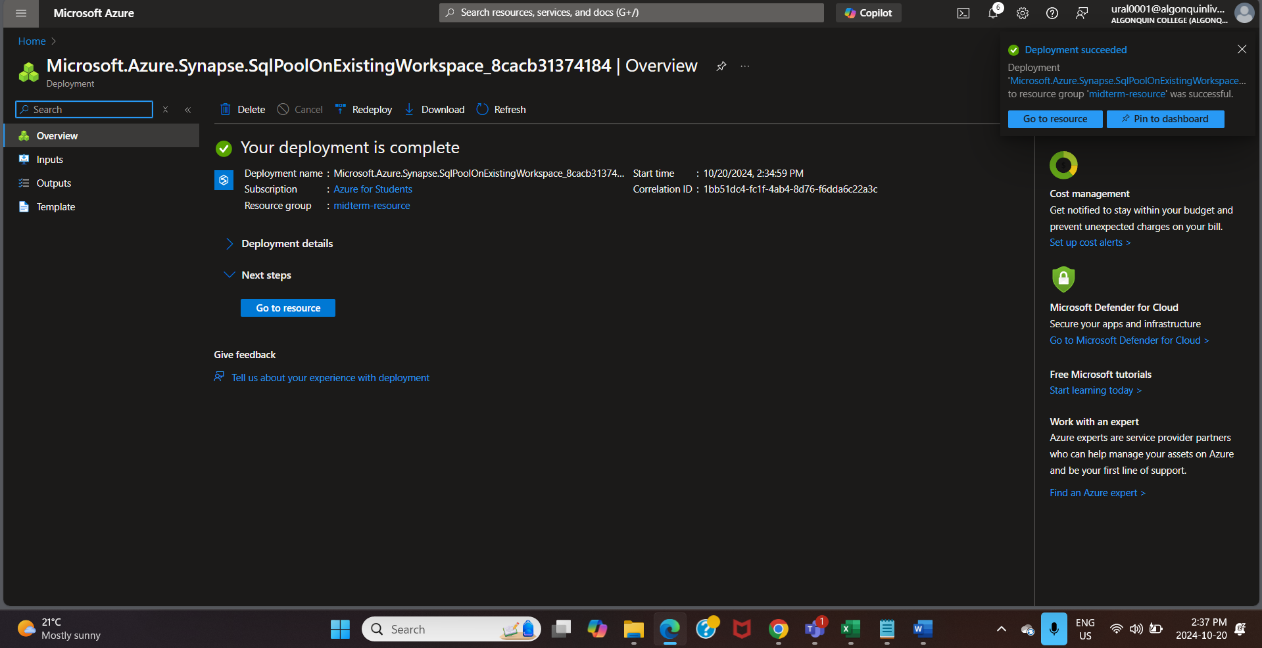

Step 8: This shows the Azure Data Studio connection interface to Microsoft SQL Server Database. This is a cross-platform database tool for managing SQL Server databases. This platform provides options to either connect using Parameters or Connection String and include buttons.

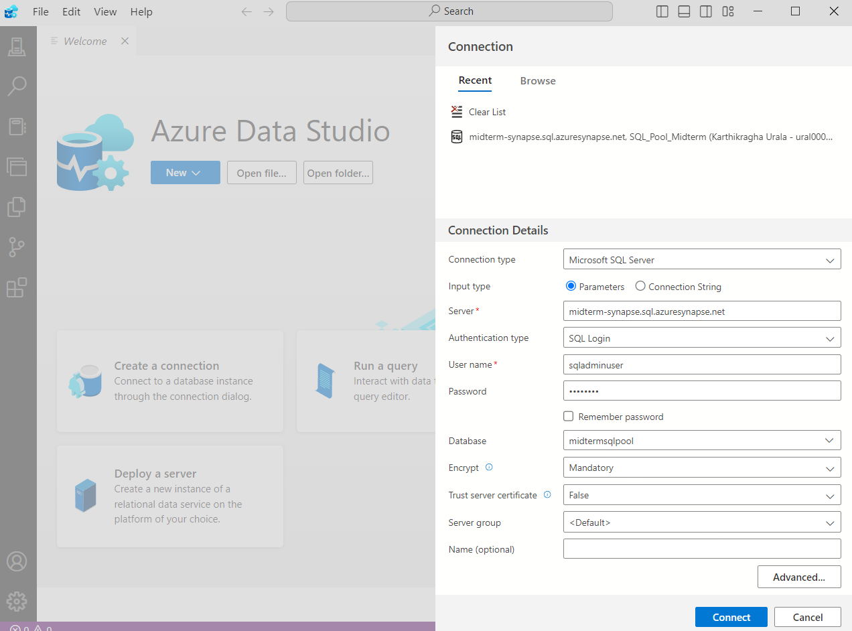

This screenshot says about the SQL Code where we are setting up external data access. It shows:

* Creation of master key encryption with a password.
* Creation of scoped credential
* Setting up an external data source pointing to Azure blob storage location.
* Creating an external file.

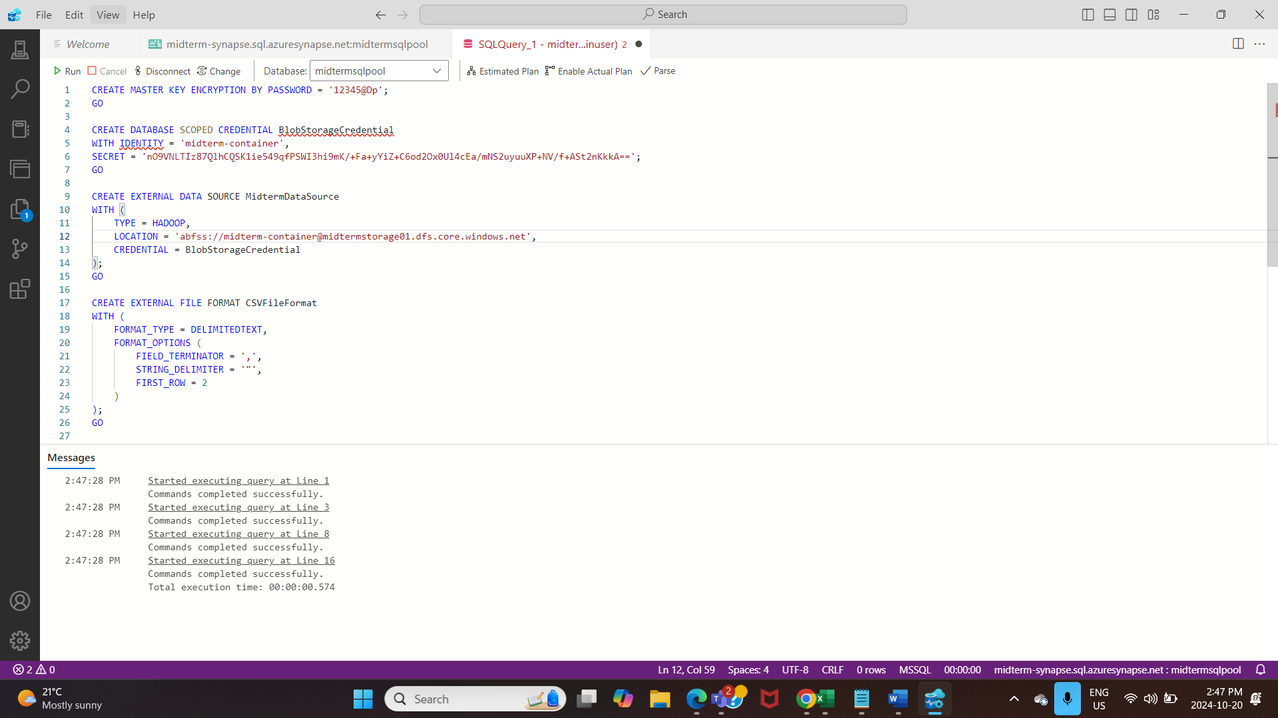

Created external table “ExternalEmployeeData” in order to ensure the querying is not done on the original production database. 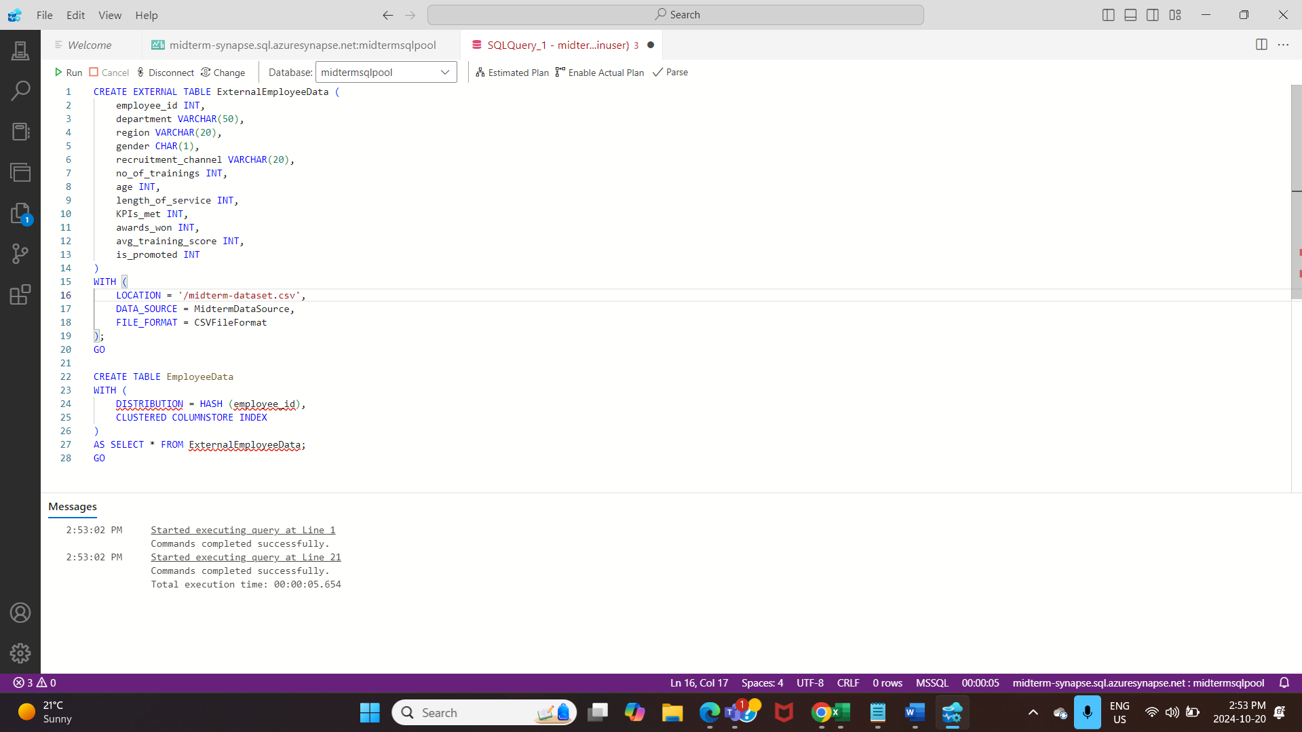

INPUT

Created a view called “DepartmentPromotionRate”. This shows the employees demographics and promotion statistics.

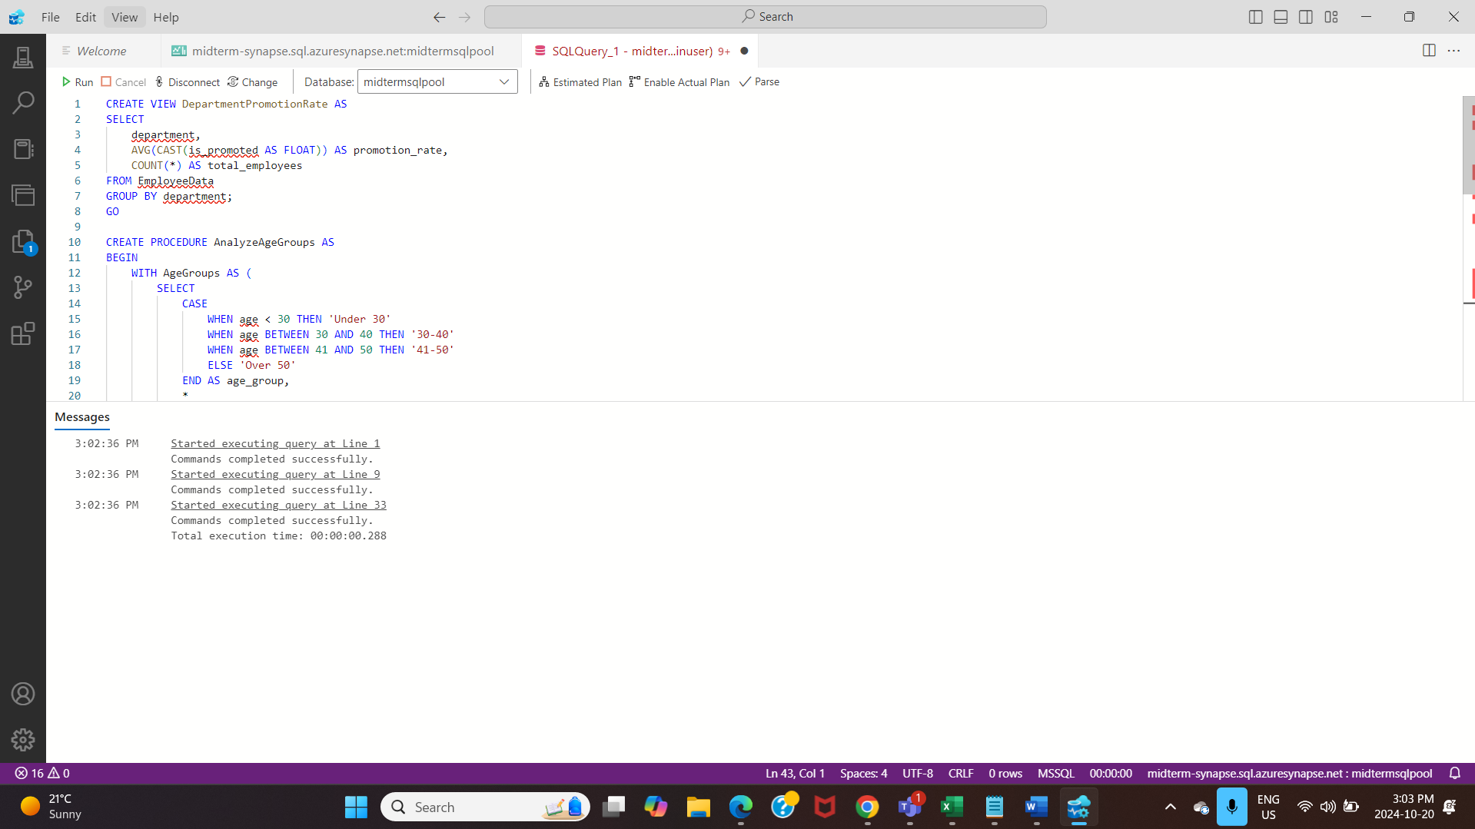

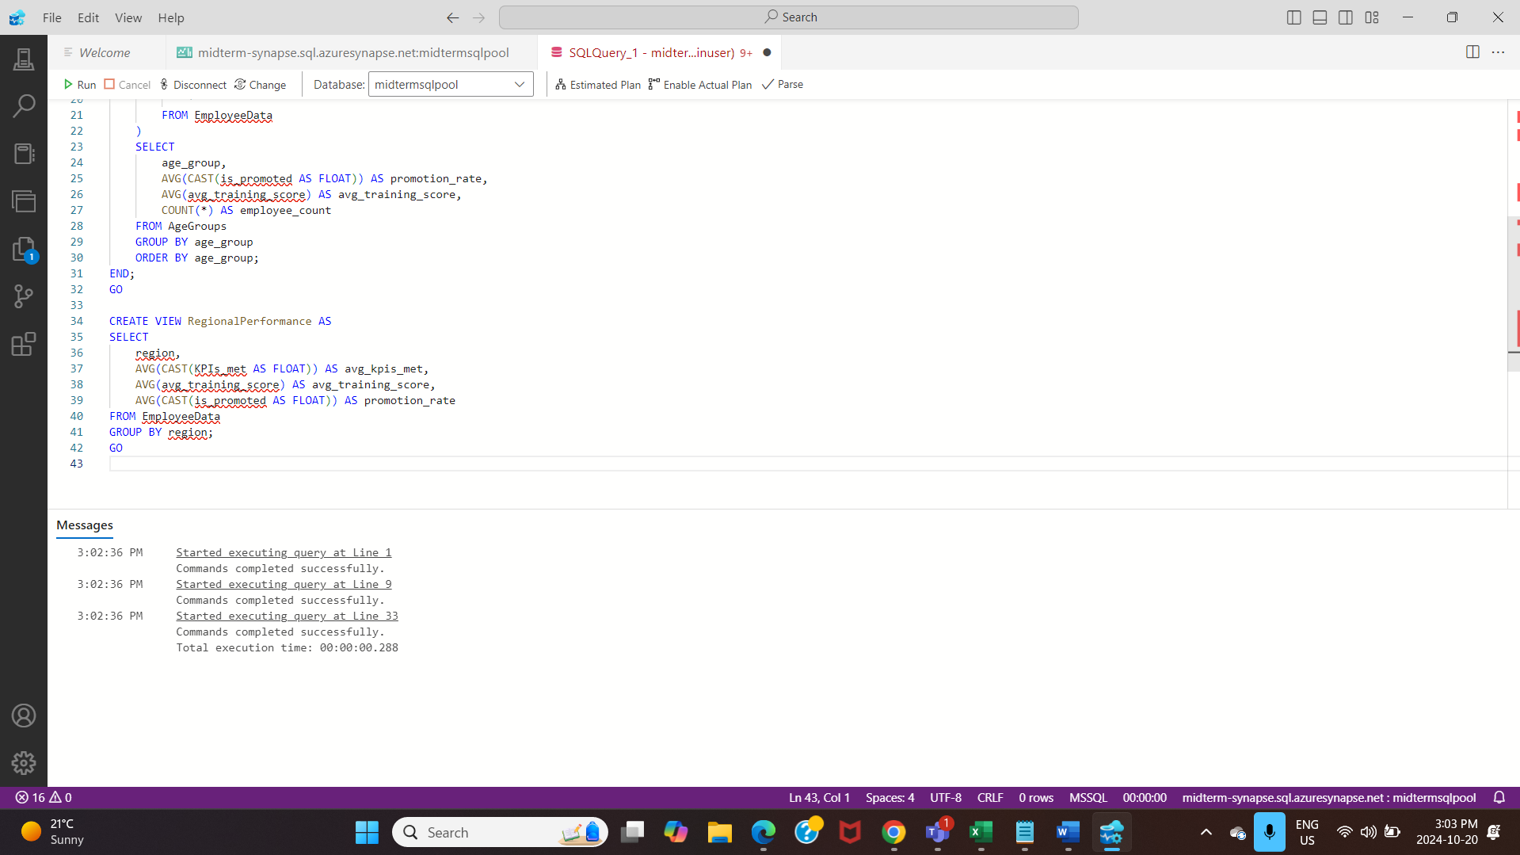OUTPUT:

Query result from “DepartmentPromotionRate” view, displaying department statistics ordered by promotion rate.

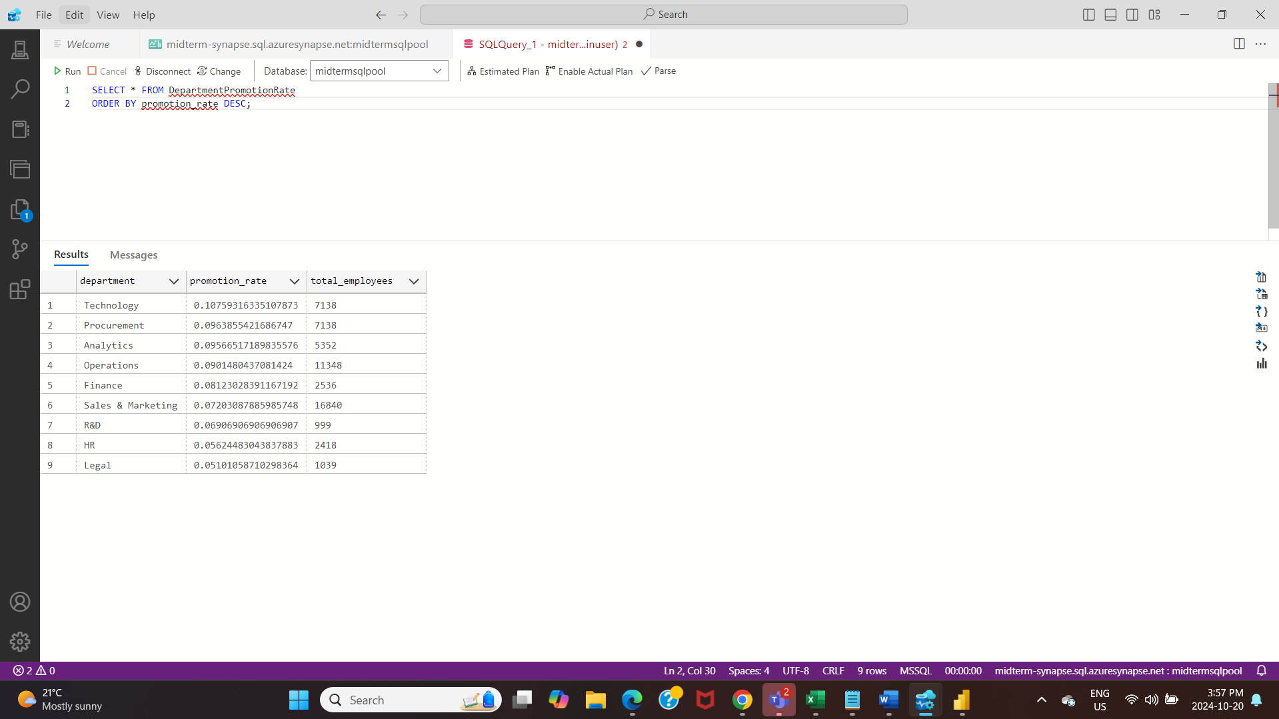

Query Result of AgeGroupAnalysis and KPIImpactonPromotions.

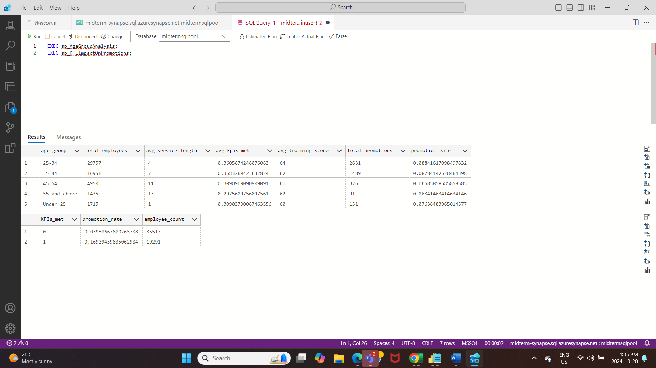

Query Result of average of the employees that met the KPI’s by regional performance and arranging them by descending order.

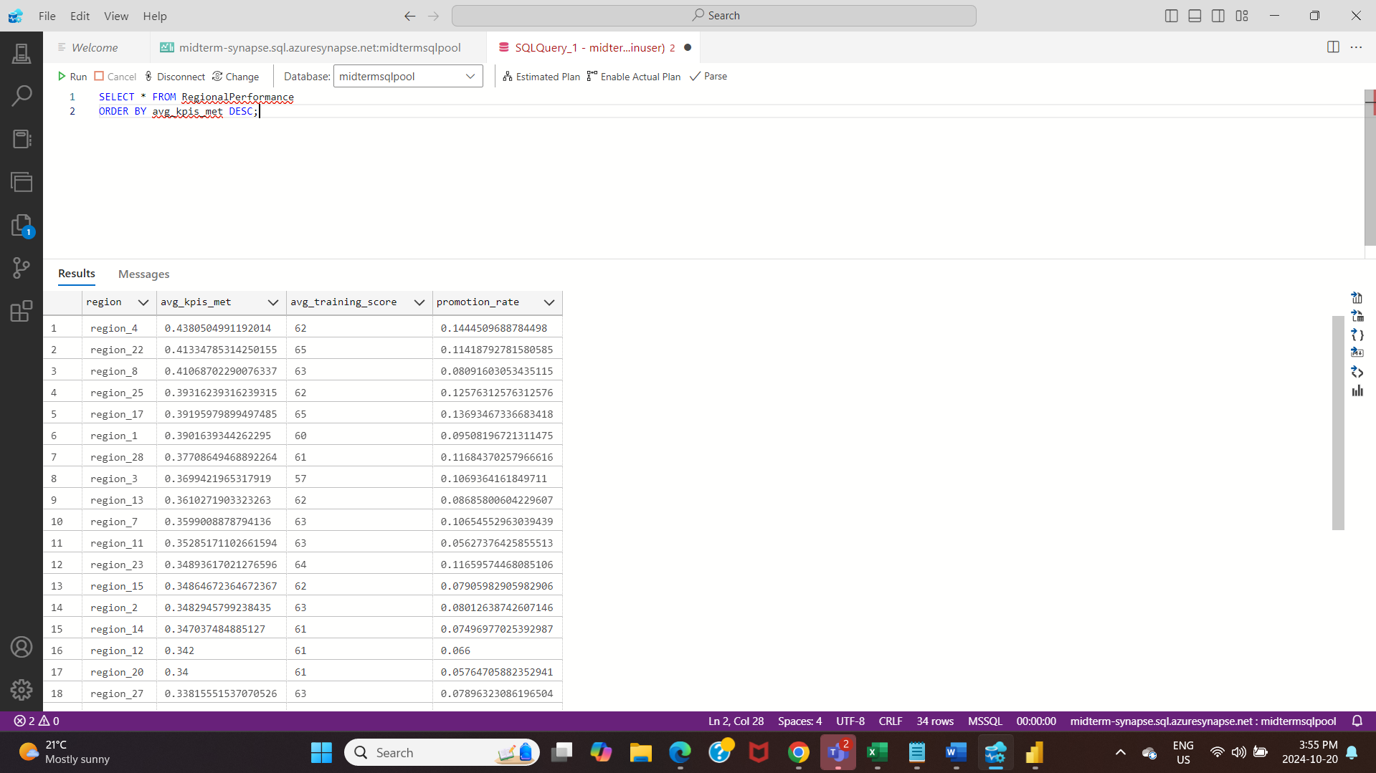

INPUT

Created a view named "servicelengthimpactonpromotions" showing length of service statistics.

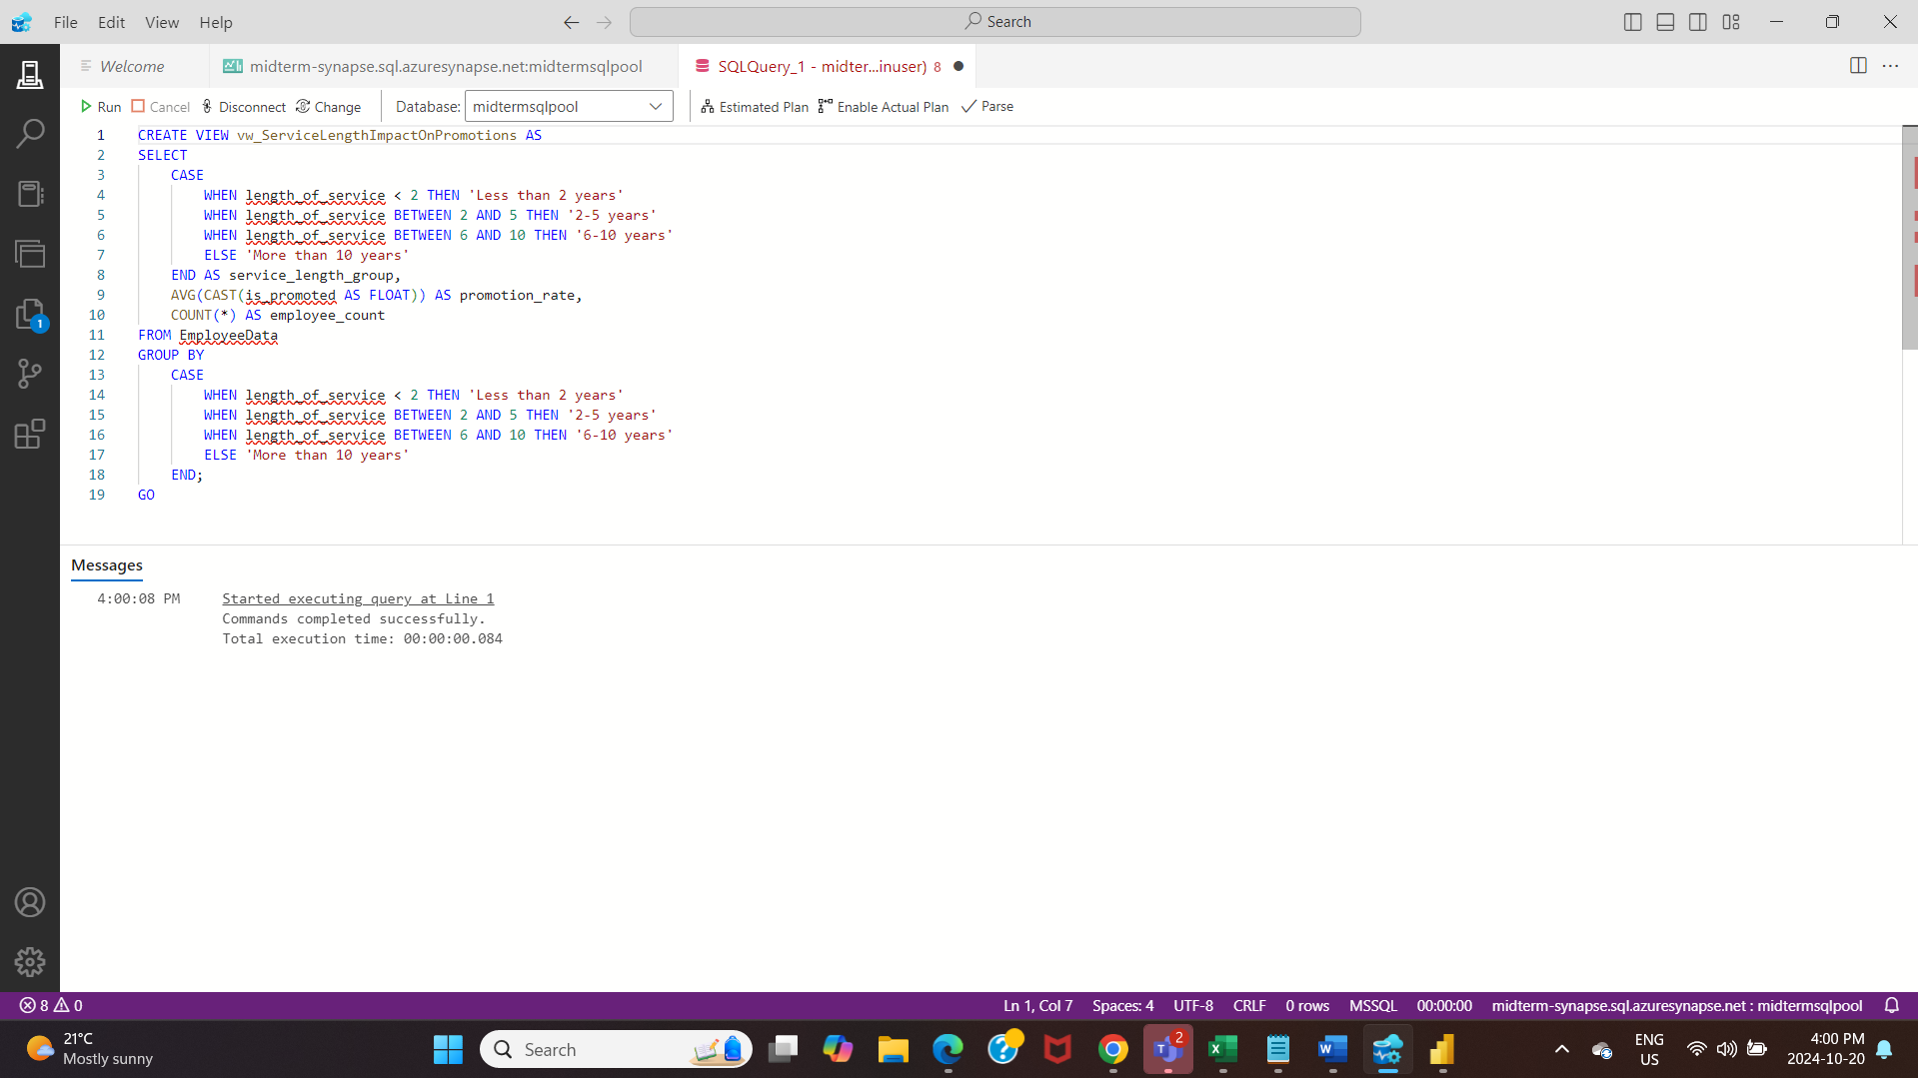

OUTPUT

Query result of Service length vs promotion data.

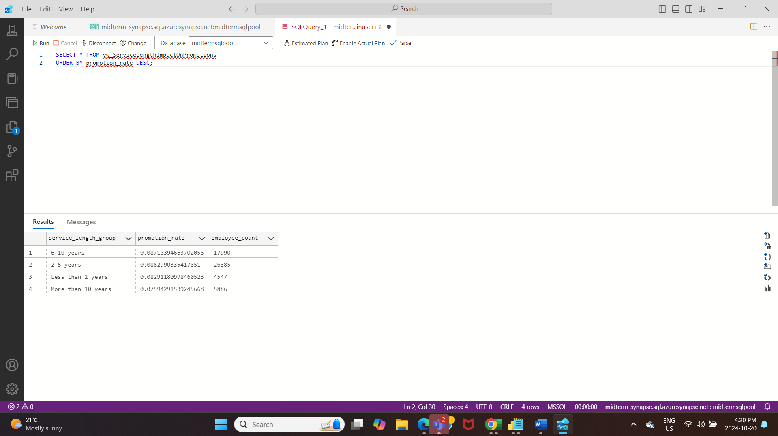

INPUT

Created a view named "KPIImpactOnPromotions " showing KPI statistics.

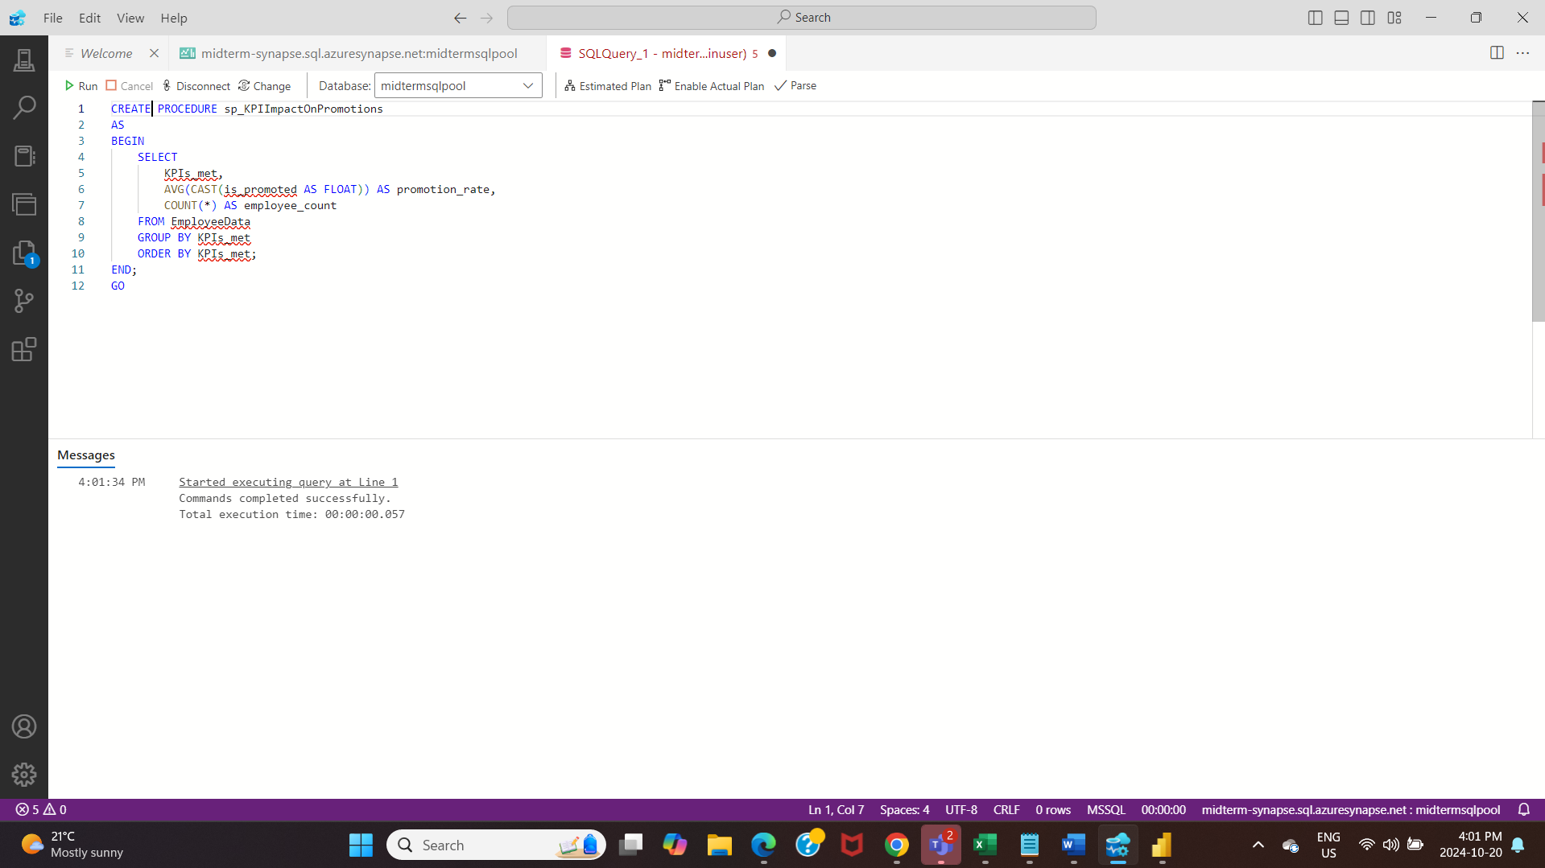

OUTPUT:

Query Result of KPI’s met with promotion rate and the number of employees who got “promoted” and “not promoted”.

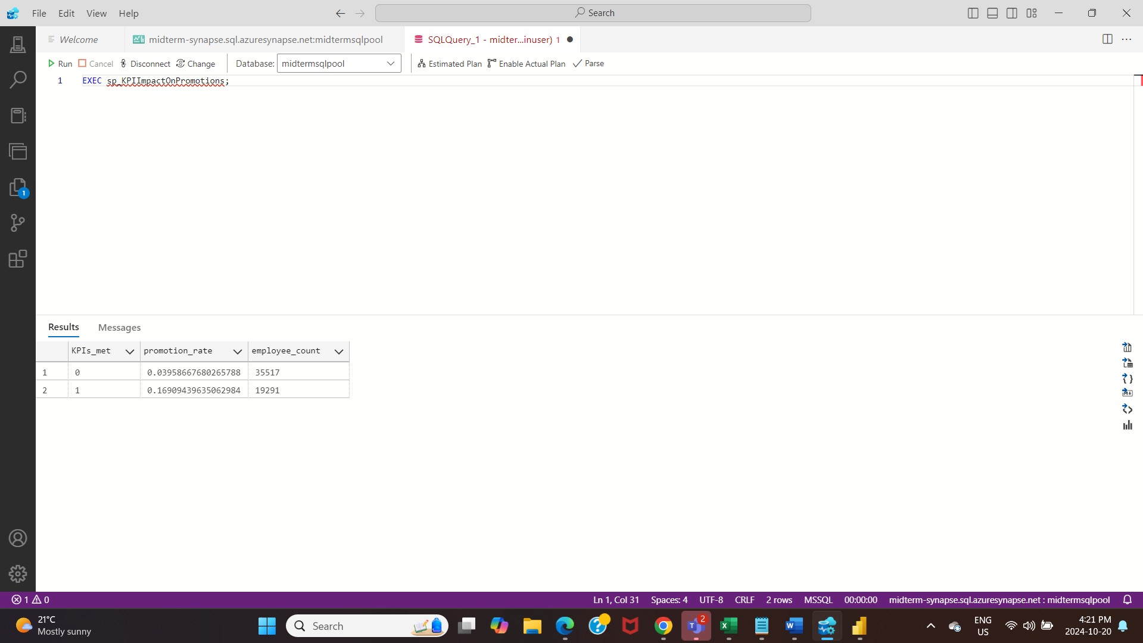

INPUT

Query to create “AgeGroupAnalysis” where you can differentiate the age according to the categories.

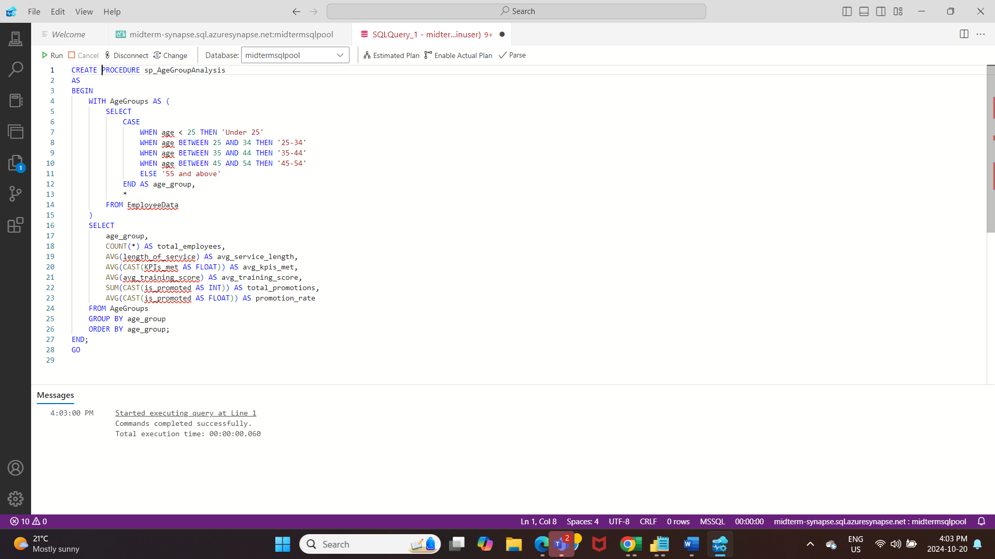

OUTPUT

Query Result of AgeGroupAnalysis

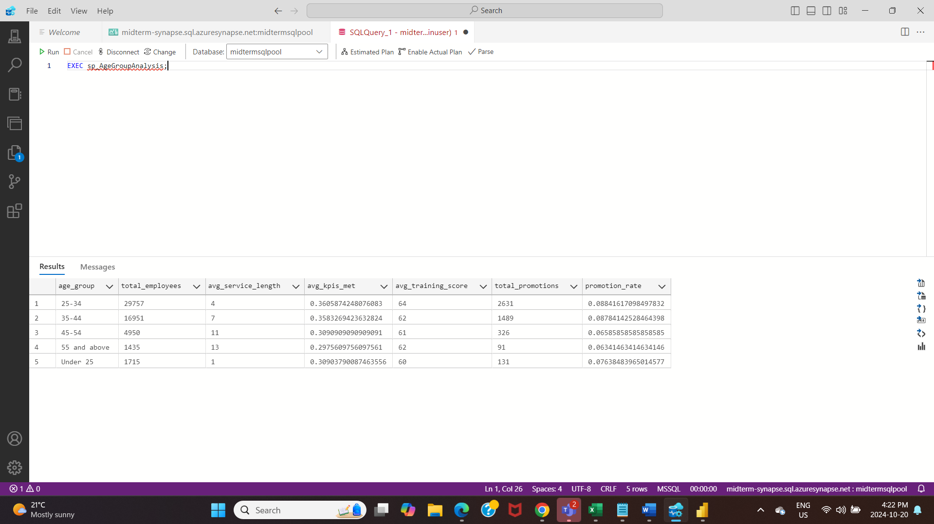

INPUT

Query showing comprehensive department performance metrics including salary trends and promotion rates.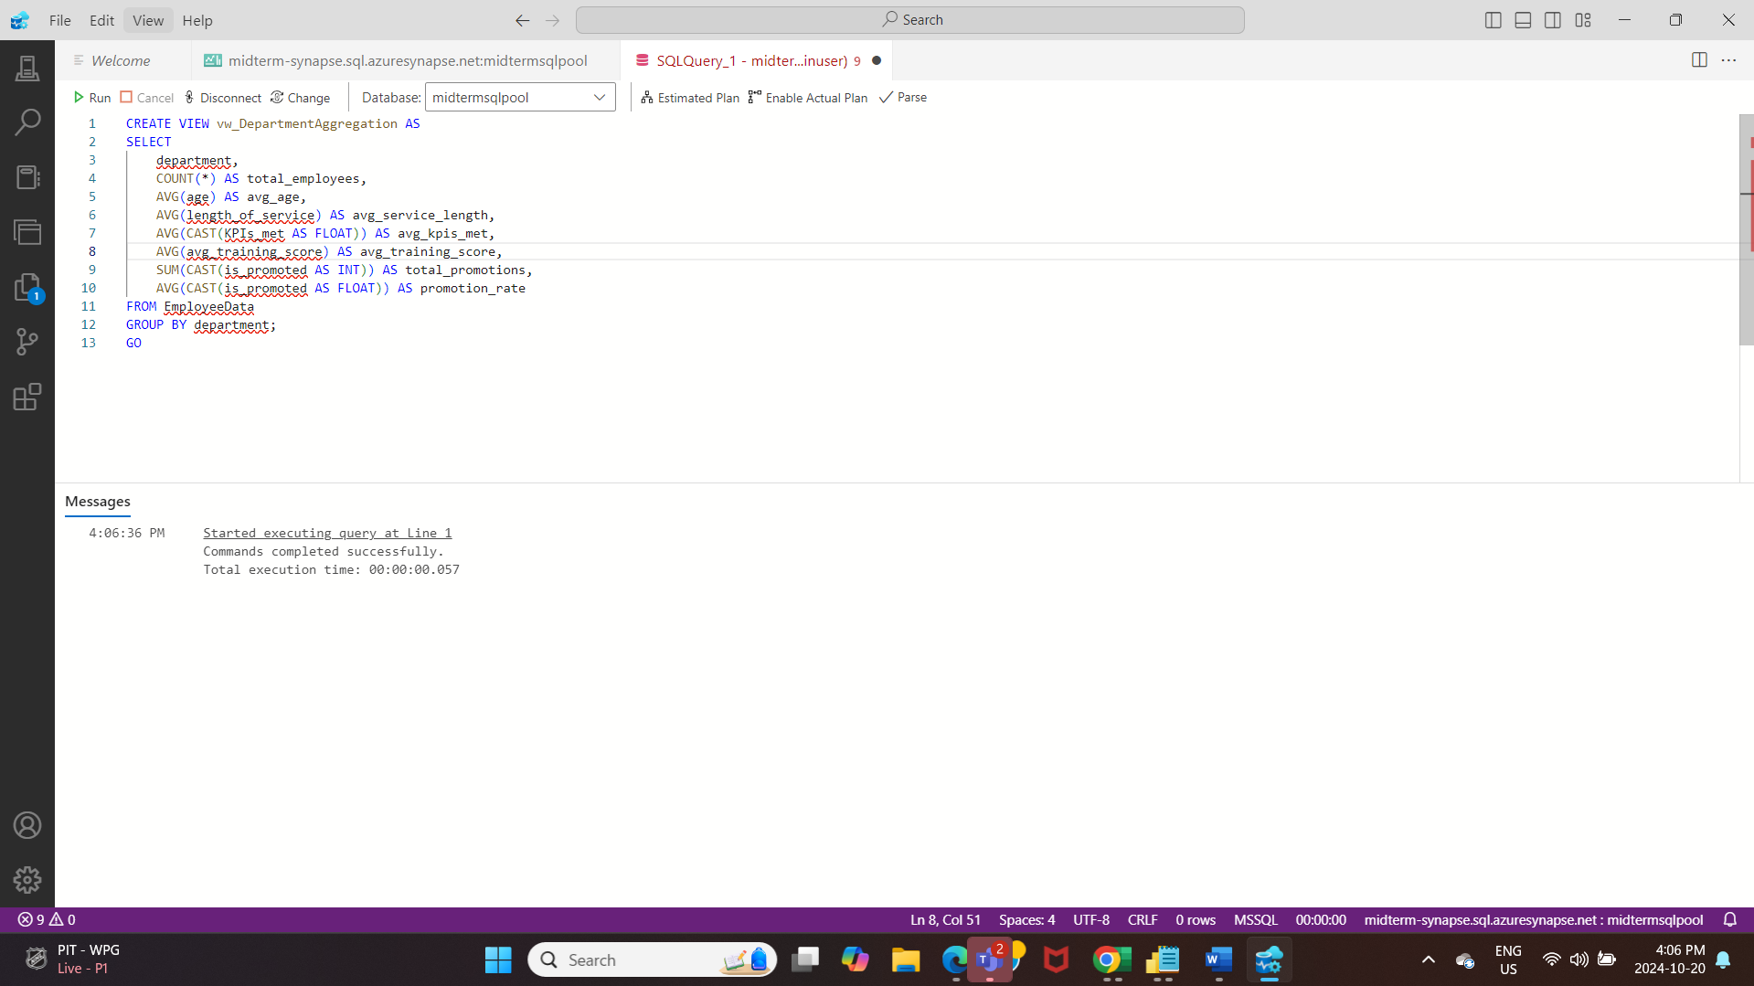

OUTPUT:

Final query result.

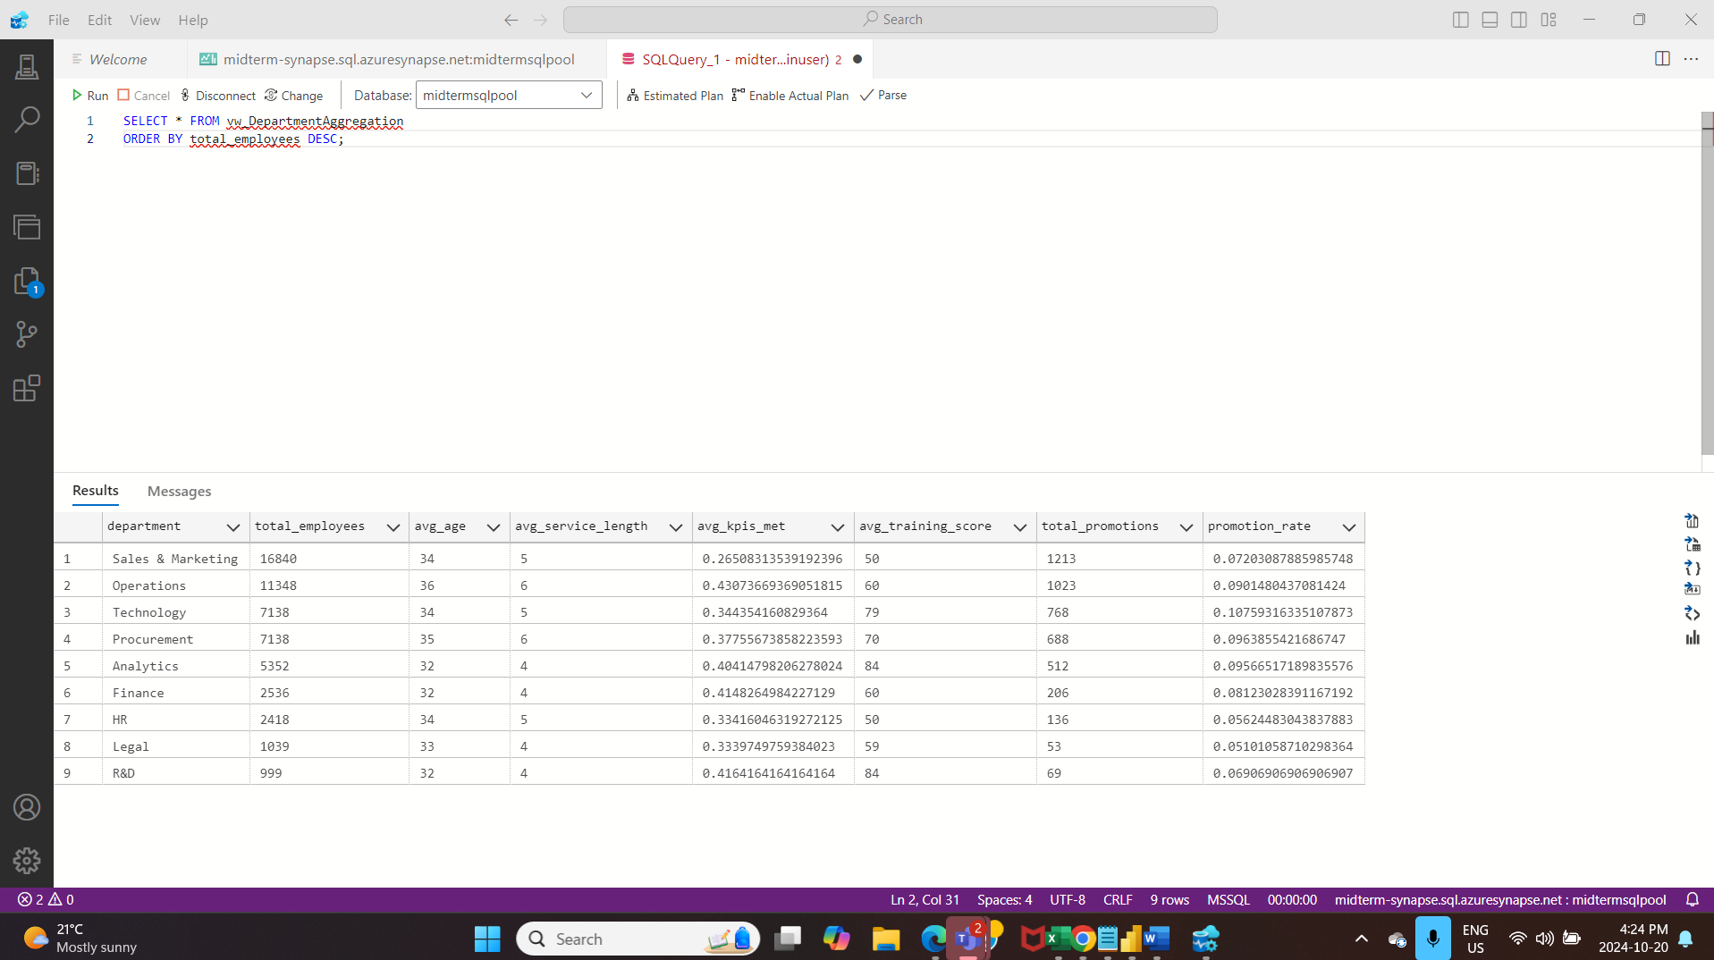

To view departments with above-average promotion rates:

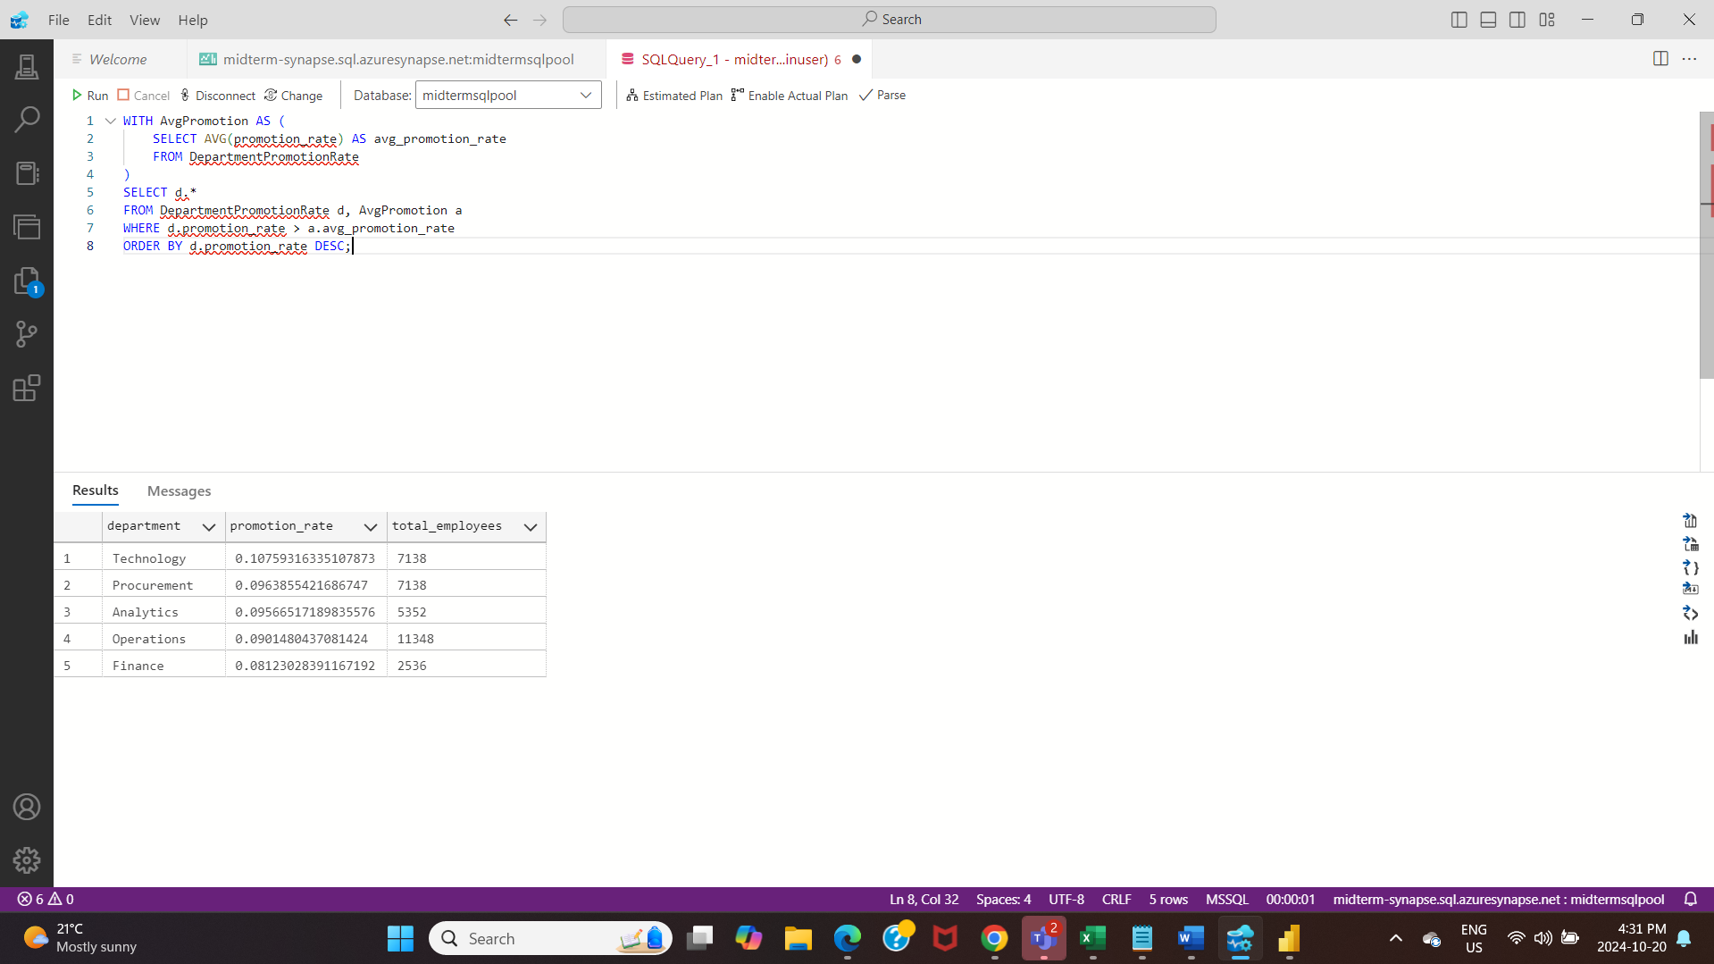

INPUT

Created a view named "RegionAggregation".

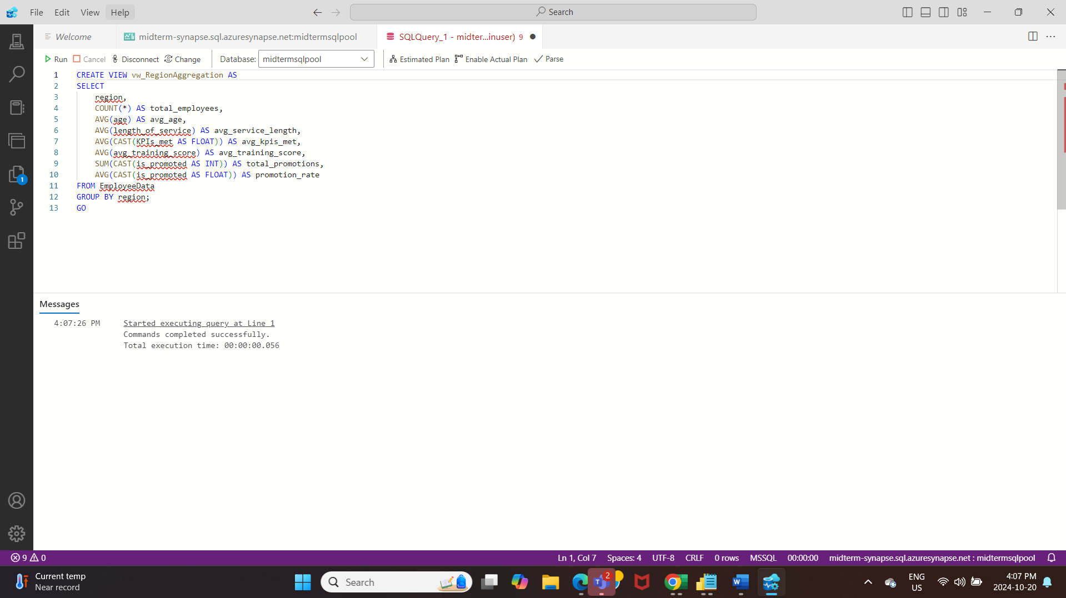

OUTPUT

Query Result of RegionAggregation.

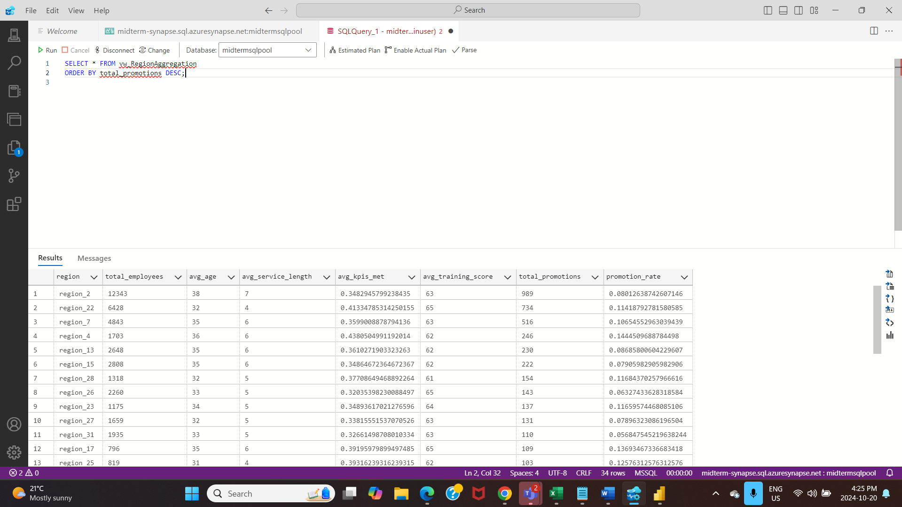

INPUT

Created a View named “vw_TrainingImpactOnPromotions”.

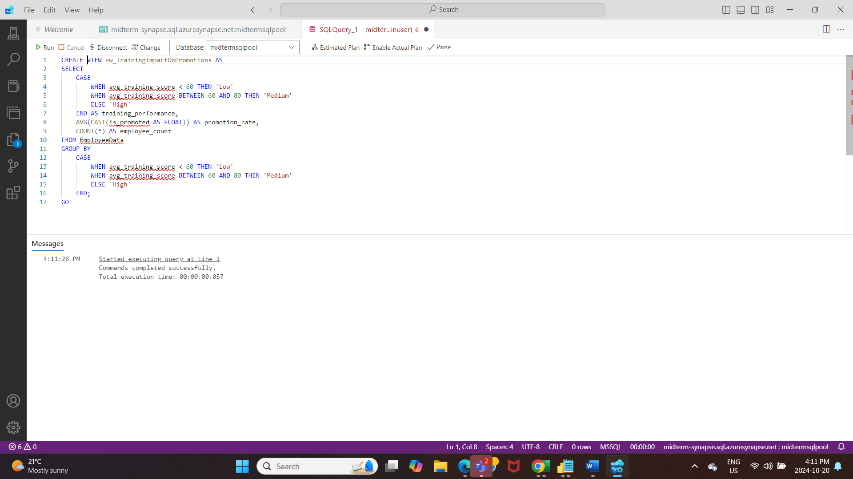

OUTPUT

Query Result of vw_TrainingImpactOnPromotions

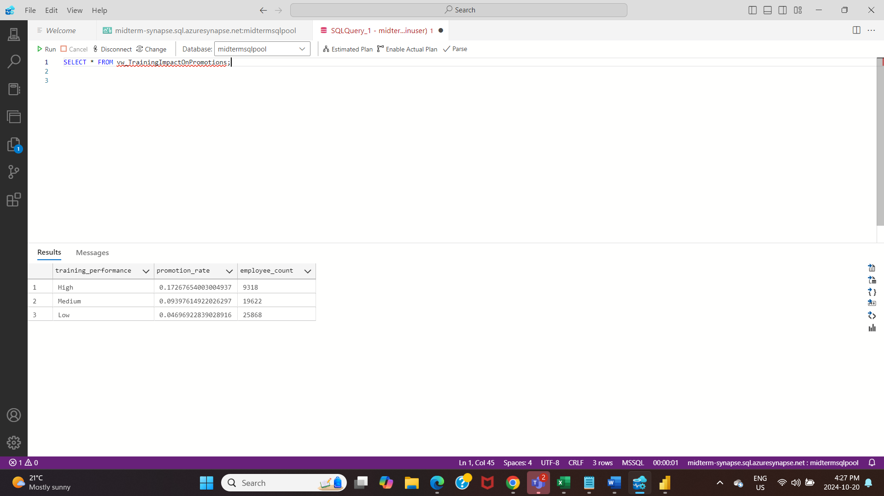

Deleted all the resources.

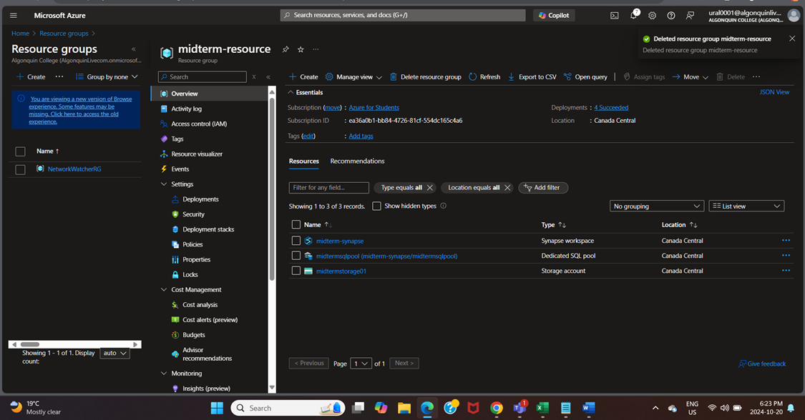

**Power BI report**

Data Modelling

The data model displays tables with critical relationships connecting them, such as RequiredPerformance, DepartmentPromotionHistory, and EmployeeData, which explain how employee data relates to department history and performance indicators. The connections most likely interconnect employee IDs and department IDs across different tables using primary and foreign keys.

* EmployeeData is the main table and is most likely the source of employee-specific data (e.g., employee_id, name).
* DepartmentPromotionHistory is linked to EmployeeData, which uses the employee_id key to track each employee's department and promotion history.
* Using the employee_id key, RequiredPerformance links to EmployeeData to track performance goals and accomplishments.
* Employee_id-linked external or supplementary information about employees may be stored in ExternalEmployeeData.
* Service-related information and tenure may be recorded in tables such as TenureInMonthsData and ServiceListingMapping, which are probably linked to departments or personnel via shared keys.

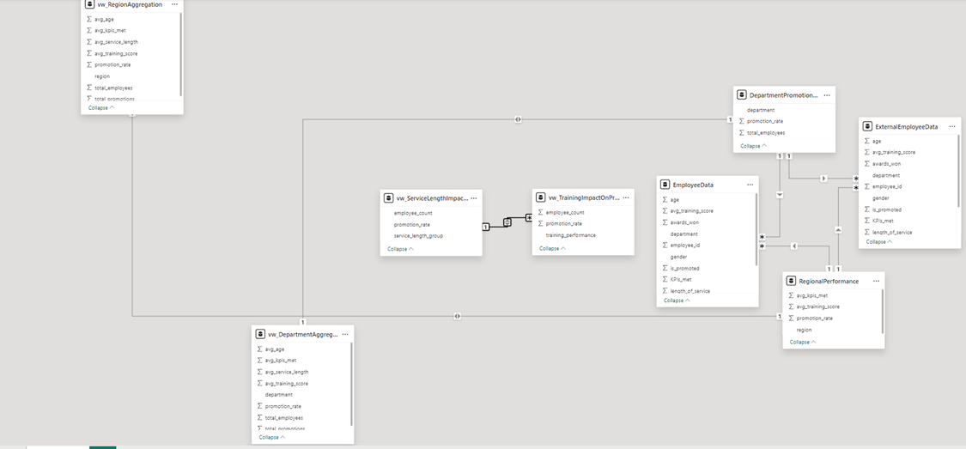

**Dashboard**

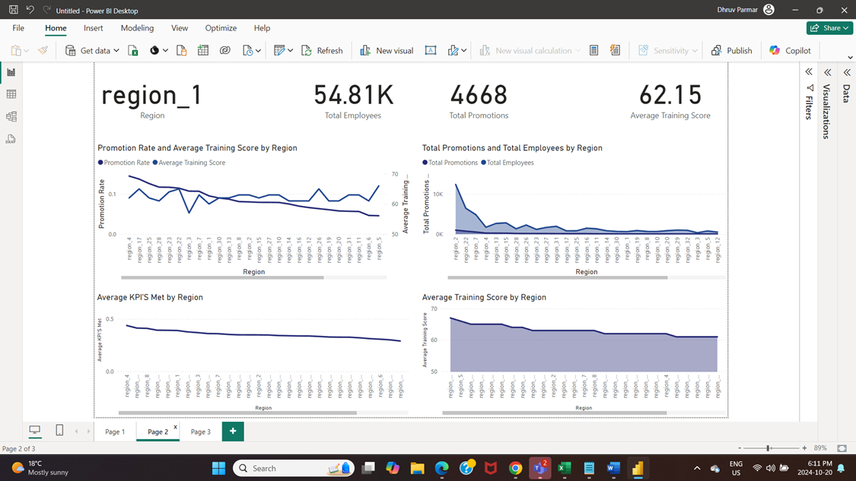

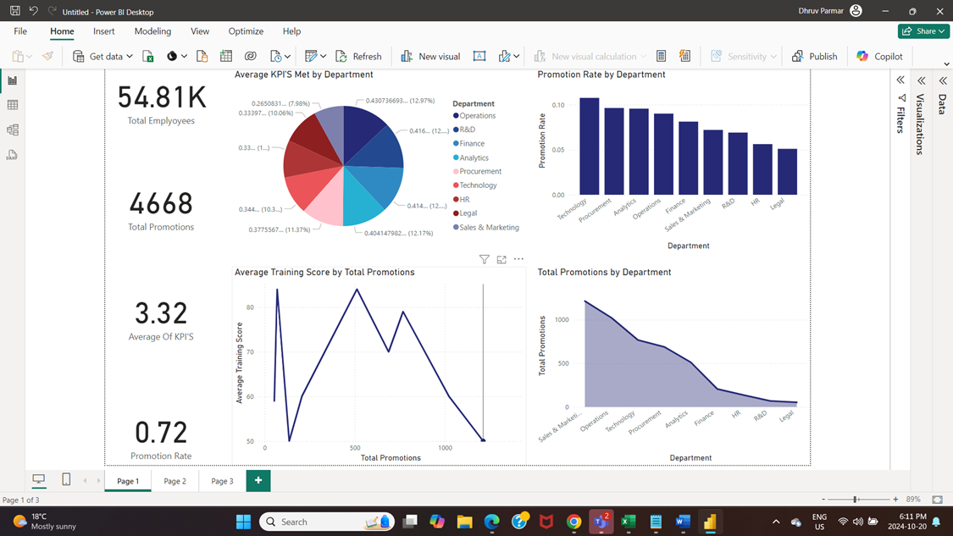

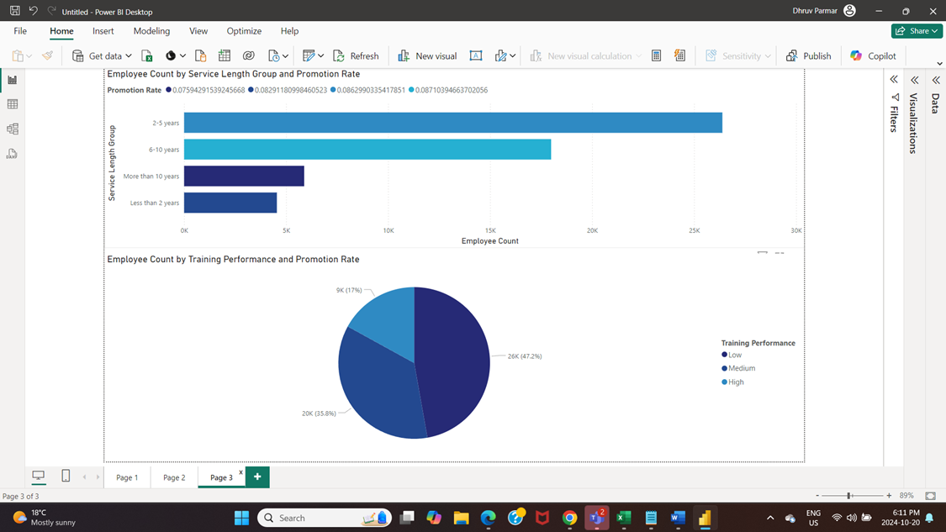

Insights

* The employee count is seen highest in 2-5 years by service length and promotion rate and lowest in less than 2 years.
* Average KPI’s met is gradually decreasing when compared with different regions.
* Average Training score is directly promotional to Total Promotions i.e; if employee’s training score is high, he/she is entitled to get a promotion.
* You can see highest number of promotions in region 2 and lowest in region 12.
* Sales and marketing department has the highest number of promotions in their team while legal team has the lowest.